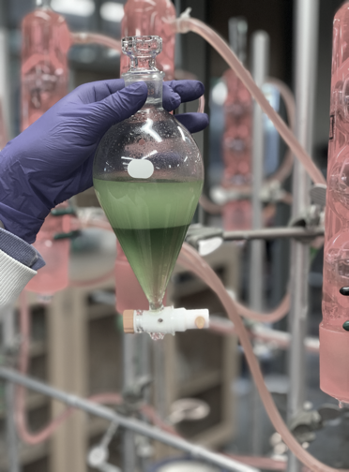
On
On behalf of the Mississippi State Chemical Laboratory (MSCL), I would like to thank you for showing interest in MSCL and in learning more about the testing of hemp material. Listed in this brochure are some summarized points of interest regarding the submission of hemp samples for analytical testing.

Sincerely,

Ashley Meredith
Director of Industrial and Agricultural Services
Mississippi State Chemical Laboratory
http://www.mscl.msstate.edu
310 Presidents Circle
Mississippi State, MS 39762
ameredith@mscl.msstate.edu
(662) 325-7803
Thank you for considering the MSCL for your testing needs!
Congue nihil imperdiet doming id quod mazim placerat facer minim veni am ut wisi enim ad minimeniam, quis erat nostr uexe
rci tation ullamcorper nostru exerci tation ullam corper et iusto odio dig nissim qui blandit praesent lupta. Tummer delenit
augue duis dolore te feugait nulla facilisi. Con erattis sectetuer adip iscing elit, sed erat diam nonummy nibh magna erat.
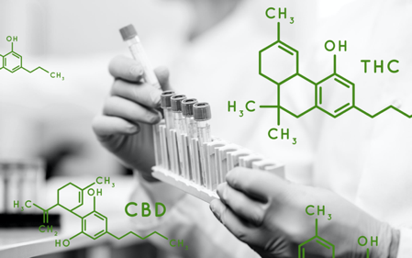
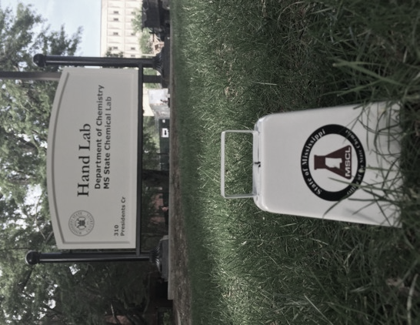
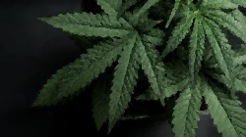
Contact us at
662-325-3324
or email us at info@mscl.msstate.edu
Visit our Website at
www.mscl.msstate.edu
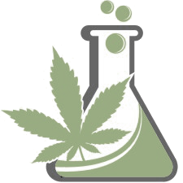

Mississippi State Chemical Laboratory
Hand Lab 1145
310 Presidents Circle
Mississippi State, MS 39759
HEMP Testing Services & Helpful Hints:
Mississippi State Chemical Laboratory

CANNABINOIDS  5+ cannabinoids (including THC) + Moisture  Minimum 2 gram sample | $75.00 | /lot
HEAVY METALS  Arsenic, Cadmium, Lead, and Mercury  Minimum 1 gram sample | $150.00 | /lot
PESTICIDES  25+ commonly used pesticides  Minimum 2 gram sample | $200.00 | /lot
MYCOTOXINS  Ochratoxin A, Aflatoxin B1, B2, G1, and G2  Minimum 2 gram sample | $100.00 | /lot
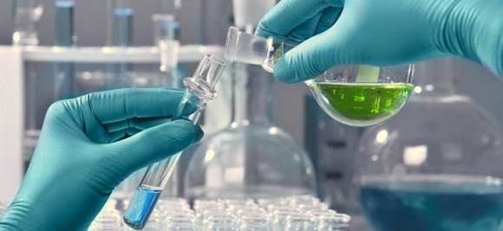
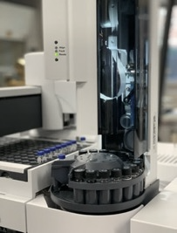
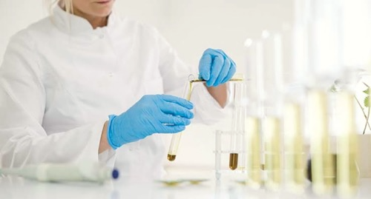
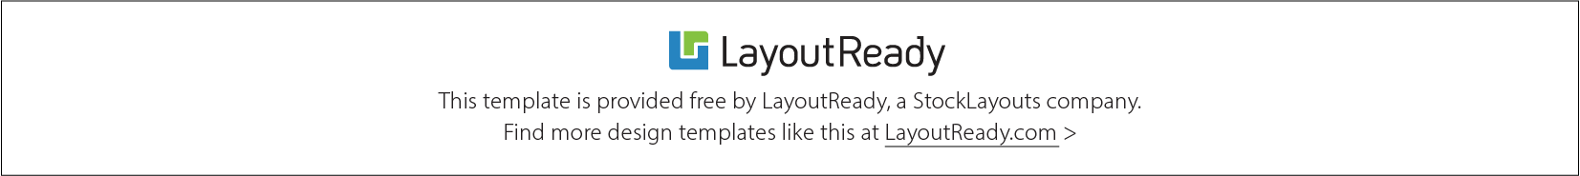
Feel free to contact us with any questions.

662-325-3324 or info@mscl.msstate.edu

Submission Package shall contain:
- Sample Submission Form(s)
- Sample(s)
- Hemp Sample Collection Acknowledgement (copy)
- An Authorization Number/Producer Hemp License
- Payment

Submission Form (to be sent with package): Can be located on the MSCL website.
Payment Options: Credit Card (2.7% convenience fee), Purchase Order, Money Order, Cash, or Check
Address: MSCL
Hand Laboratory (RM 1145)
310 Presidents Circle
P.O. Box CR
Mississippi State, MS 39762
What to expect:
- Testing results (THC content) within 10 business days of sample(s) receive date.
- Additional testing options: Metals, Pesticides, and Mycotoxins/Total Aflatoxins.

Submission of Samples:
- Flower material sampled (generally, ≥ 1 gram), within the top 3rd of the hemp plant.
- Licensed producers must arrange for the collection/shipping of samples by a USDA-approved agent.
- Sampling occurs 15 days or less from harvest.
- Samples should be collected in a new/unused paper bag, 1 bag per lot (e.g. 2 lots, 2 bags). Gloves should be changed, and sampling equipment cleaned with rubbing alcohol or bleach between lots.
- The typical sampling procedure calls for one plant sampled for every acre in a lot.
- Bags should be sealed to avoid cross contamination and uniquely labeled with permanent marker per lot for identification and be accompanied with sample submission form.
- More information can be found in the USDA’s Sampling Guideline for Hemp Growing Facilities. https://www.ams.usda.gov/sites/default/files/media/SamplingGuidelinesforHemp.pdf
- Samples can be mailed or delivered to the MSCL; the MSCL is registered by the DEA for tetrahydrocannabinol (THC) testing.
Sampling Information:
Pricing Guide
Imperdiet doming id quod mazim placerat facer minim veni am ut wisi enim ad minimeniam, quis erat nostr uexerci tation ullam corper nostru exerci tation ullam corper et iusto odio dig nissim qui blandit praesent lupta. Tummer delenit augue duis dolore te feud iam nonummy nibh magna erat aliquam erat volutpat.

